
U.prabhavathi
U.Prabhavathiz
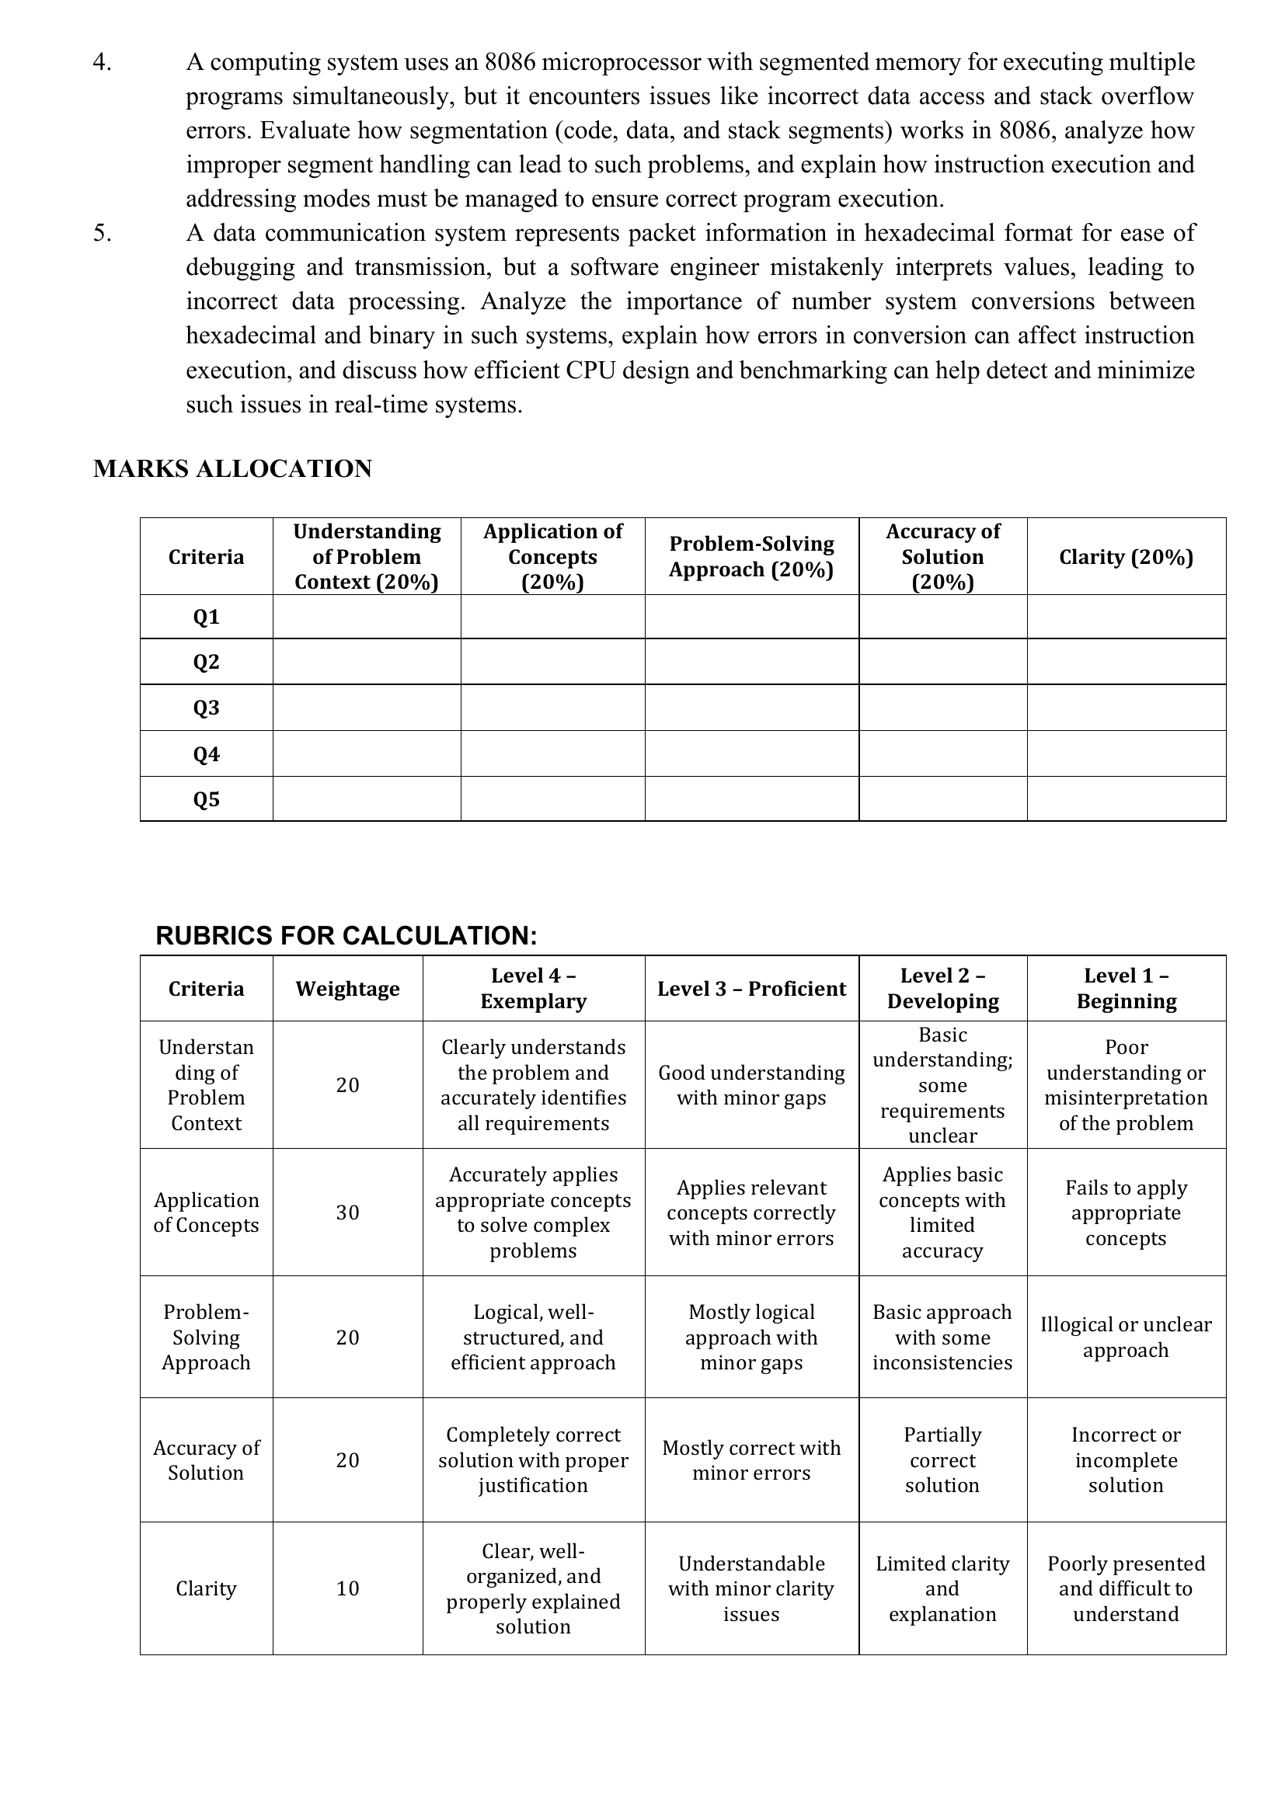
Question 1: Smart City Surveillance System
Introduction
A Smart City Surveillance System is an advanced security system that uses multiple CCTV cameras, sensors, and intelligent software to monitor public places such as roads, railway stations, airports, shopping malls, and government buildings. The cameras continuously capture video data, which is transferred through Input/Output (I/O) devices to the computer's memory (RAM). The CPU processes the video using image processing and artificial intelligence algorithms to detect suspicious activities.
During peak hours, hundreds of cameras generate a large amount of video data every second. Since the CPU, memory, and I/O devices communicate continuously, the communication bus becomes busy, resulting in delays. Efficient bus architecture and instruction execution techniques are therefore essential for maintaining real-time performance.
Applications
Smart city monitoring
Traffic management
Crime detection
Airport security
Railway station surveillance
Shopping mall security
Military surveillance
Example
Suppose 100 cameras send Full HD video simultaneously. If the CPU uses a single bus, it must wait for memory access, causing delays. A multi-bus architecture allows multiple data transfers simultaneously, reducing lag.
+----------------------+
| CCTV Cameras |
| (Input Devices) |
+----------+-----------+
|
| Video Frames
v
+----------------------+
| I/O Controller |
+----------+-----------+
|
| Data Transfer
v
+----------------------+
| Main Memory |
| (RAM) |
+----------+-----------+
^
| Fetch / Store Data
|
+----------+-----------+
| CPU |
| Fetch • Decode |
| Execute • Process |
+----------+-----------+
|
| Threat Detection
v
+----------------------+
| Alert / Display / |
| Police Notification |
+----------------------+
FLOWCHART
START
│
▼
Capture Video from Cameras
│
▼
Transfer Data to RAM
│
▼
CPU Fetches Video Frames
│
▼
Decode & Process Frames
│
▼
Threat Detected?
┌────┴────┐
Yes No
│ │
▼ ▼
Generate Continue
Alert Monitoring
│
▼
END
Related C Program (Simulation)
#include <stdio.h>

int main()
{
int cameras = 5;

for(int i=1;i<=cameras;i++)
{
printf("Camera %d Frame Captured\n",i);
printf("Processing Frame...\n");
printf("Threat Detection Completed\n\n");
}

return 0;
}

Question 2: Real-Time Stock Trading System
Introduction
A Real-Time Stock Trading System executes millions of buy and sell transactions every second. Every transaction is processed by the CPU through the Fetch–Decode–Execute cycle. When millions of instructions are executed continuously, the processor may experience a high Cycles Per Instruction (CPI) due to memory access delays and branch instructions.
High CPI increases execution time, resulting in delayed transaction processing. Modern processors reduce CPI using cache memory, pipelining, branch prediction, superscalar execution, and out-of-order execution.
Applications
Online stock exchanges
Banking systems
Online payment gateways
Cryptocurrency trading
Financial analytics
High-frequency trading (HFT)
Example
If a processor executes 10 million instructions with a CPI of 4, execution takes longer than a processor with a CPI of 2.
DIAGRAM
+------------------+
| Memory |
| (Program & Data) |
+---------+--------+
|
Fetch Instruction
|
v
+------------------+
| CPU |
| Control Unit |
+---------+--------+
|
Decode
|
v
+------------------+
| Arithmetic Logic |
| Unit (ALU) |
+---------+--------+
|
Execute
|
v
+------------------+
| Store Result in |
| Memory/Register |
+------------------+
FLOWCHART
START
│
▼
Receive Trading Request
│
▼
Fetch Instruction from Memory
│
▼
Decode the Instruction
│
▼
Execute Buy/Sell Transaction
│
▼
Update Memory & Database
│
▼
Transaction Successful?
┌─────┴─────┐
Yes No
│ │
▼ ▼
Display Success Display Error
│
▼
END

Related C Program
#include <stdio.h>

int main()
{
int transactions = 5;

for(int i=1;i<=transactions;i++)
{
printf("Transaction %d Processed Successfully\n",i);
}

return 0;
}

Question 3: 8085 Temperature Control System
Introduction
The 8085 microprocessor is an 8-bit microprocessor widely used in embedded systems and industrial automation. In a temperature control system, sensors continuously measure temperature and send the data to the 8085 microprocessor. The processor compares the measured temperature with the desired value and controls actuators such as heaters or cooling fans.
The correct addressing mode is essential because it determines how data is accessed. Using an incorrect addressing mode may result in reading the wrong sensor value or storing incorrect information in memory.
Applications
Industrial automation
Boiler control
Air conditioning systems
Smart irrigation
Medical equipment
Temperature monitoring systems
Example
If the sensor measures 35°C but the processor reads data from the wrong memory location, it may display 80°C, causing incorrect control of the heating system.
DIAGRAM
+------------------+
| Temperature |
| Sensor |
+--------+---------+
|
| Temperature Data
▼
+------------------+
| Input Port |
+--------+---------+
|
▼
+------------------+
| 8085 |
| Microprocessor |
+--------+---------+
|
Compare Temperature
|
+--------+---------+
| |
Yes No
| |
▼ ▼
Turn ON Cooling Continue Monitoring
System
|
▼
+--------------+
| Output Port |
+------+-------+
|
▼
Cooling Fan / Alarm

FLOWCHART
START
│
▼
Read Temperature Sensor
│
▼
Store Temperature in Register
│
▼
Compare with Reference Temperature
│
┌───────┴────────┐
│ │
Temperature Temperature
> Limit ≤ Limit
│ │
▼ ▼
Turn ON Fan Continue Monitoring
│ │
└───────┬────────┘
▼
END
8085 Assembly Program
MVI A,25H
OUT 01H
IN 00H
STA 2050H
HLT
Program Explanation
MVI A,25H → Load value into Accumulator.
OUT 01H → Send data to output port.
IN 00H → Read sensor data.
STA 2050H → Store data in memory.
HLT → Stop program execution.

Question 4: 8086 Segmentation
Introduction
The 8086 microprocessor is a 16-bit processor that uses segmented memory architecture to access up to 1 MB of memory. Memory is divided into four segments:
Code Segment (CS) – Stores program instructions.
Data Segment (DS) – Stores variables and data.
Stack Segment (SS) – Stores return addresses and local variables.
Extra Segment (ES) – Stores additional data.
The physical address is calculated using the formula:
Physical Address = Segment × 16 + Offset
If segment registers are not initialized correctly, the processor may access incorrect memory locations, leading to data corruption or stack overflow.
Applications
Embedded systems
Industrial control systems
Operating systems
Robotics
Automotive electronics
Medical devices
Example
If:
CS = 2000H
Offset = 1234H
Then:
Physical Address = 2000H × 10H + 1234H
= 21234H
DIAGRAM
8086 Microprocessor
│
┌─────────────┬─────────────┬─────────────┬─────────────┐
│ │ │ │
▼ ▼ ▼ ▼
Code Segment Data Segment Stack Segment Extra Segment
(CS) (DS) (SS) (ES)
│ │ │ │
└─────────────┴─────────────┴─────────────┘
│
▼
Physical Address Calculation
Segment × 16 + Offset
8086 Assembly Program
MOV AX,DATA
MOV DS,AX

MOV AX,1234H
PUSH AX

POP BX

HLT
FLOWCHART
START
│
▼
Initialize Segment Registers
│
▼
Fetch Instruction
│
▼
Calculate Physical Address
│
▼
Access Code/Data/Stack Memory
│
▼
Execute Instruction
│
▼
Store Result
│
▼
END
Program Explanation
MOV AX,DATA → Load data segment.
MOV DS,AX → Initialize Data Segment.
MOV AX,1234H → Load a value into AX.
PUSH AX → Push the value onto the stack.
POP BX → Pop the value into BX.
HLT → Stop execution.

Question 5 – Number System Conversion in Data Communication
Introduction
In a data communication system, information is often represented in hexadecimal (Hex) format because it is shorter and easier for engineers to read than binary. However, the CPU executes all instructions in binary (0s and 1s). Therefore, hexadecimal values must be converted accurately into binary before processing.
If a software engineer incorrectly converts a hexadecimal value into binary, the CPU may execute the wrong instruction, access the wrong memory location, or transmit incorrect packet data. Efficient CPU design, error detection techniques, and benchmarking help identify and reduce these errors, improving the reliability of real-time communication systems.
Applications
Computer networks
Internet communication
Routers and switches
Embedded systems
IoT devices
Satellite communication
Mobile communication
Cybersecurity
Example
Suppose a packet contains the hexadecimal value:
Hexadecimal : 3A
Convert it into binary:
3 = 0011
A = 1010

Binary = 00111010
If it is mistakenly converted as:
00110110
the CPU may interpret it as different data or a different instruction, leading to incorrect packet processing.
C Program – Hexadecimal to Binary Conversion
#include <stdio.h>

int main()
{
int num, i;

printf("Enter a hexadecimal number: ");
scanf("%x", &num);

printf("Binary Equivalent: ");

for(i = 31; i >= 0; i--)
{
printf("%d", (num >> i) & 1);
}

return 0;
}
Sample Output
Enter a hexadecimal number: 3A

Binary Equivalent:
00000000000000000000000000111010
Program Explanation
%x reads the input as a hexadecimal number.
The for loop checks each bit from the most significant bit (31) to the least significant bit (0).
The expression (num >> i) & 1 extracts one bit at a time.
The binary equivalent is displayed on the screen.
Advantages
Easy debugging of packet data.
Faster representation than binary.
Reduces programming errors.
Improves communication efficiency.
Simplifies memory address representation.
Conclusion
Accurate conversion between hexadecimal and binary is essential for correct CPU instruction execution and reliable data communication. Modern processors use error detection, efficient memory management, and benchmarking techniques to improve performance and reduce processing errors in real-time systems.

